**1. Top Categories by Total Price**

**Question Statement**: Identify and visually represent the top 10 product categories by total sales.

**Visualization**: 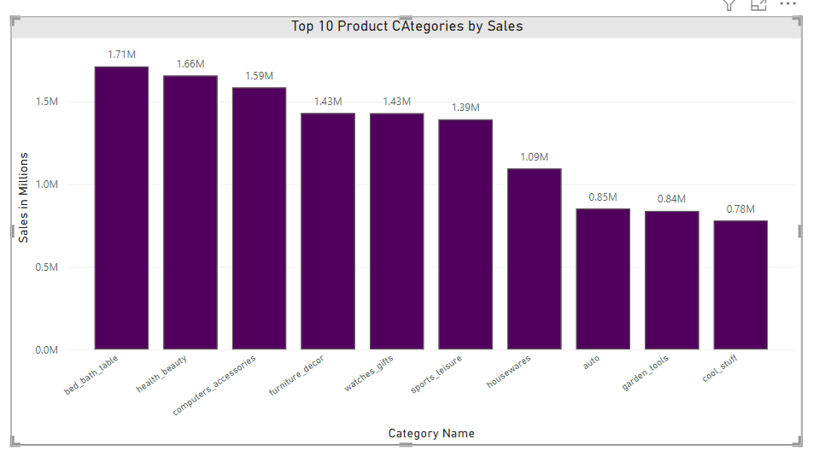

**Explanation** : The bar chart above provides an overview of the total sales across the top 10 product categories. This visualization is instrumental in identifying the categories that contribute most significantly to overall revenue, enabling the business to focus efforts on its strongest performers.

The **top 10 product categories** by total sales are as follows:

1. **Bed, Bath & Table: $1.71M**
2. **Health & Beauty: $1.66M**
3. **Computer Accessories: $1.59M**
4. **Furniture & Decor: $1.43M**
5. **Watches & Gifts: $1.43M**
6. **Sports & Leisure: $1.39M**
7. **Housewares: $1.09M**
8. **Auto: $0.85M**
9. **Garden Tools: $0.84M**
10. **Cool Stuff: $0.78M**

### ****Key Insights****:

* The **Bed, Bath & Table** category stands out with $1.71M in total sales, closely followed by **Health & Beauty** at $1.66M. Both categories demonstrate strong consumer demand and present substantial opportunities for continued growth.
* **Furniture & Decor** and **Watches & Gifts**, each contributing $1.43M in sales, also highlight significant market interest in home improvement and lifestyle products.
* While categories such as **Auto**, **Garden Tools**, and **Cool Stuff** generate relatively lower sales, they still represent key segments that may benefit from focused marketing efforts or operational adjustments to enhance performance.

#### 2. Delayed Orders Analysis

**Question Statement**: Determine the number of delayed orders in each category. An order is considered delayed if the actual delivery date is later than the estimated delivery date.

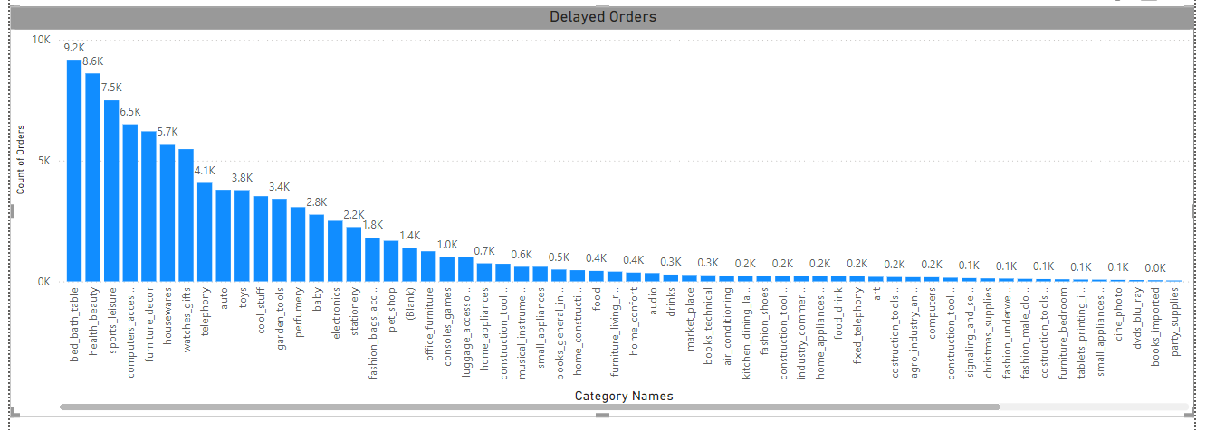**Visualization**:

**Explanation**: The bar chart above highlights the number of delayed orders across different product categories. This analysis provides valuable insight into which categories are experiencing the most delivery issues, allowing the business to pinpoint areas for improvement in logistics and ultimately enhance customer satisfaction.

The **top 10 categories** with the most delayed orders are:

1. Bed, Bath & Table
2. Health & Beauty
3. Sports & Leisure
4. Computer Accessories
5. Furniture & Decor
6. Housewares
7. Watches & Gifts
8. Telephony
9. Auto
10. Toys

### ****Key Insights****:

* **Bed, Bath & Table** and **Health & Beauty** lead the list, indicating that delays are particularly common in home goods and personal care items.
* Categories like **Sports & Leisure, Furniture & Decor**, and **Housewares** also face significant delays, likely due to issues like bulky products, packaging, or shipping logistics.
* **Telephony**, **Auto**, and **Toys** round out the list, with delays potentially tied to stock shortages, transportation problems, or fluctuations in seasonal demand.

#### 3. Monthly Comparison of Delayed and On-Time Orders

**Question Statement**: Create a dynamic visual that compares the number of delayed orders to the number of orders received earlier for each month. Utilize the drillthrough cross-report feature to provide a detailed analysis of late and on-time deliveries.

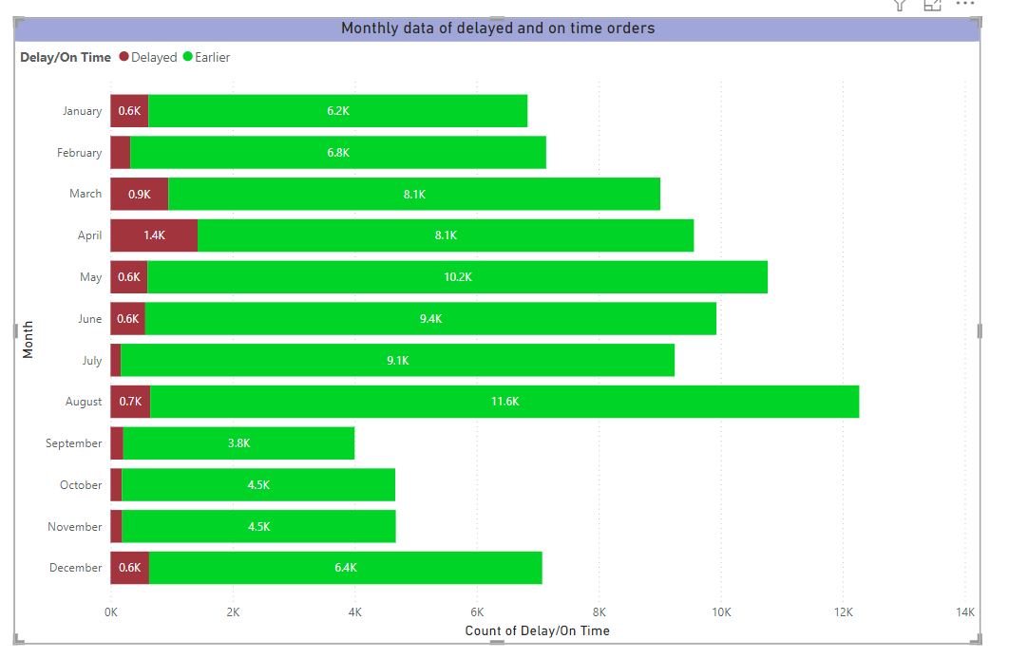**Visualization**:

**Explanation**: The stacked bar chart above compares the number of delayed and on-time orders for each month. This visualization highlights trends in delivery performance over time, allowing the business to identify patterns and take corrective actions to reduce delays. For example, the chart shows that the number of delayed orders tends to increase during peak shopping seasons, such as November and December, likely due to higher order volumes. Conversely, on-time deliveries are more consistent during off-peak months.

#### 4. Payment Method Analysis

**Question Statement**: Analyze the most frequently used payment methods by customers using a visually appealing representation, such as a pie chart or other suitable visuals.

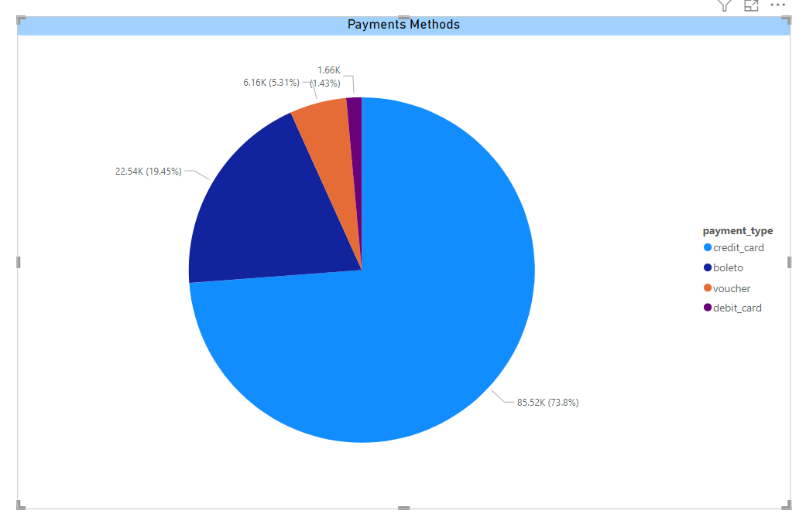**Visualization**:

**Explanation**:  The pie chart above shows the distribution of payment methods used by customers. The most frequently used payment method is credit card, followed by Boleto, Voucher, and debit card. This analysis helps understand customer preferences for payment methods, which can inform future payment options and promotions. Specifically, credit cards account for the majority of transactions, indicating a strong preference for this payment method among customers. Boleto and Voucher are also popular, while Debit cards are used less frequently.

#### 5. Product Rating Analysis

**Question Statement**: Determine the top 10 highest-rated products and the bottom 10 lowest-rated products using a bar or column chart.

**Visualisation:!** 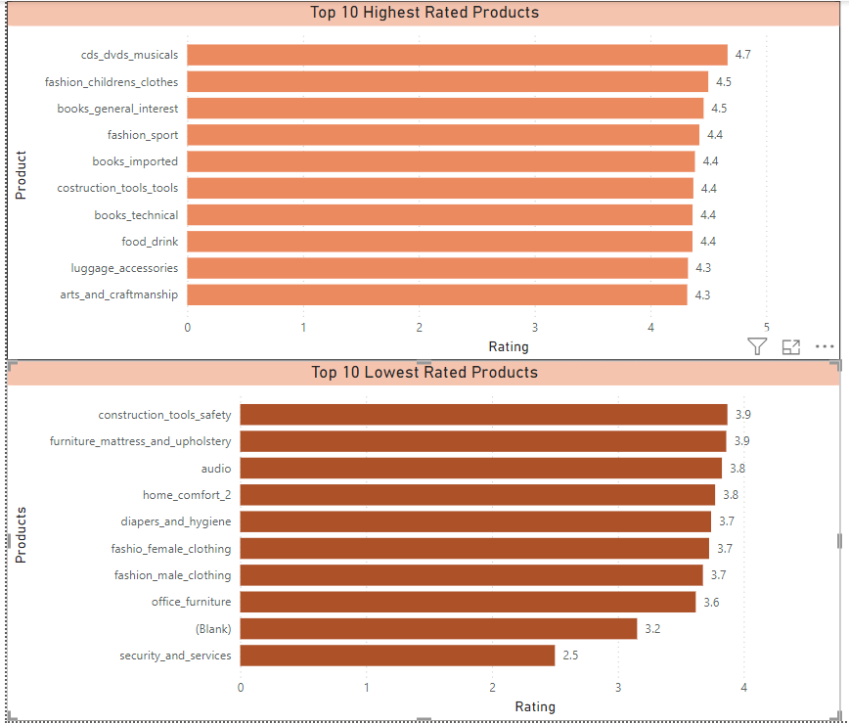

**Explanation**: The bar charts above show the top 10 highest-rated and bottom 10 lowest-rated products based on customer reviews. The highest-rated products have consistently received positive feedback, reflecting strong customer satisfaction. In contrast, the lowest-rated products have received poor reviews, which may point to potential issues with product quality or customer expectations.

#### ****Top 10 Highest-Rated Products****:

1. CDs, DVDs & Musicals
2. Fashion & Children’s Clothes
3. Books (General Interest)
4. Fashion & Sports
5. Books (Imported)
6. Construction Tools & Tools
7. Books (Technical)
8. Food & Drink
9. Luggage & Accessories
10. Arts & Craftsmanship

#### ****Top 10 Lowest-Rated Products****:

1. Construction Tools & Safety
2. Furniture (Mattresses & Upholstery)
3. Audio
4. Home Comfort
5. Diapers & Hygiene
6. Fashion (Female Clothing)
7. Fashion (Male Clothing)
8. Office Furniture
9. (Blank)
10. Security & Services

### ****Key Insights****:

* The **top-rated products**, like **CDs, DVDs & Musicals** and **Books** (both general and imported), consistently meet or exceed customer expectations, leading to high satisfaction.
* The **lowest-rated products**, including **Construction Tools & Safety** and **Furniture (Mattresses & Upholstery)**, may be experiencing quality issues or failing to align with customer needs and expectations.

**6. State-wise Sales Analysis**

**Question Statement:** Identify and visually represent states with high and low sales, providing a clear understanding of regional sales performance.

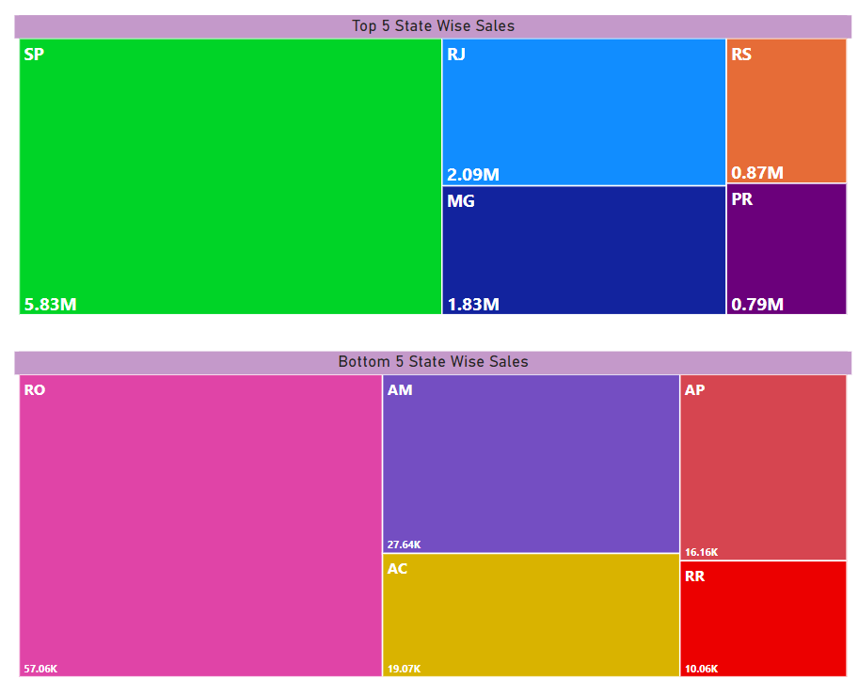**Visualization:**

**Explanation:** The map above shows the total sales by state. States with higher sales are highlighted, indicating regions with strong market presence. This analysis helps identify key markets and regions that may require targeted marketing efforts or sales strategies. For example, states like São Paulo, Rio de Janeiro, and Minas Gerais show high sales, indicating strong market presence and potential for further growth. On the other hand, states with lower sales may benefit from targeted marketing campaigns to boost sales.

### Key Insights:

1. **High-Sales States:**
   * **São Paulo**, **Rio de Janeiro**, and **Minas Gerais** are performing well, showing high sales. These regions are key markets for us, and there’s potential for further growth. We should focus on maintaining customer loyalty and exploring new product offerings to expand our share in these states.
2. **Low-Sales States:**
   * Some states show lower sales, suggesting that our products may not be as well-known or available. These areas could benefit from targeted marketing campaigns, local promotions, and improving distribution to increase product visibility and drive sales.

**7. Seasonal Sales Patterns**

**Question Statement:** Investigate and visualize any seasonal patterns (Quarterly) or trends in sales data over the course of the year.

**Visualization :** 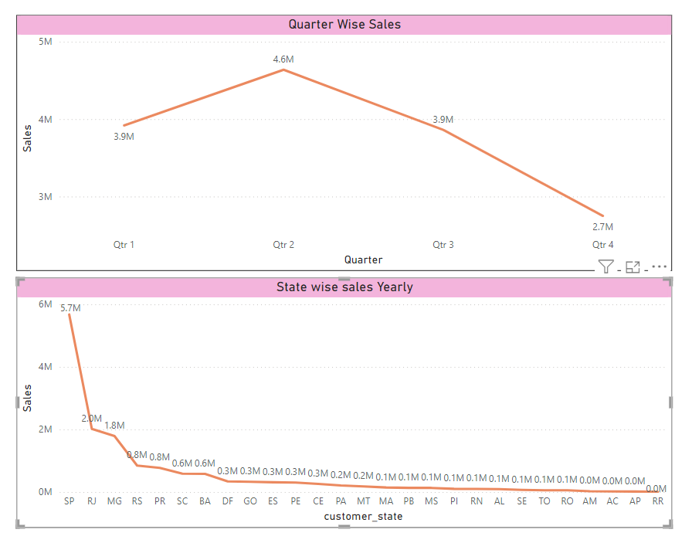

**Explanation:** The line chart above illustrates the sales trends by quarter over three years. Seasonal patterns can be observed, with certain quarters showing higher sales volumes. For example, Q4 typically shows a spike in sales, likely due to holiday shopping. This analysis helps in planning inventory, marketing campaigns, and resource allocation based on seasonal demand.

### Key Insights:

1. **Q4 Sales Spike:**
   * Sales are **higher in Q4** (October to December), likely due to the **holiday season**, when consumers tend to buy more.
2. **Fluctuating Sales in Other Quarters:**
   * **Q1** (January to March) shows **lower sales**, possibly after the holiday season.
   * **Q2** and **Q3** show more **steady sales**, but can vary depending on market conditions.

**8. Revenue Analysis**

**Question Statement:** Determine the total revenue generated by ShopNest Store and analyze how it changes over time (Yearly). Represent this information through suitable visuals to highlight trends and patterns.

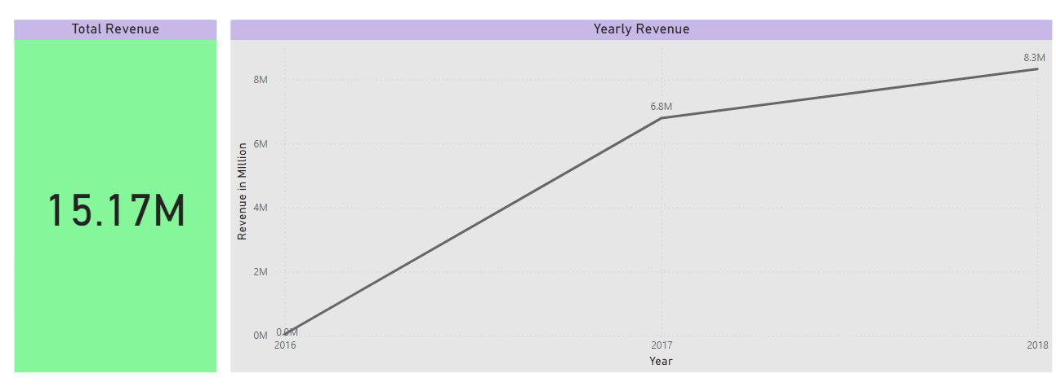**Visualization :**

**Explanation:** The line chart above shows the total revenue generated by ShopNest Store over the years, with a total revenue of $15.17M. The trend indicates growth or decline in revenue, providing insights into the store's financial performance. This analysis helps in strategic planning and forecasting future revenue. For example, the chart shows a steady increase in revenue over the years, highlighting the store's growth and market expansion.

### Key Insights:

1. **Steady Revenue Growth:**
   * The chart shows a **consistent increase** in revenue over the years, indicating that ShopNest Store is **growing** and performing well.
2. **Strong Financial Performance:**
   * The total revenue of **$15.17M** reflects a strong financial position for the store, showing that it is successfully generating significant income.
3. **Positive Growth Trend:**
   * The ongoing increase in revenue suggests that ShopNest Store is expanding its market presence and is on track for **future growth.**